Written by: Shreya Badchariya

Going Global: How Cohere's Multilingual Model is Helping Businesses Connect and Succeed Worldwide



## The Challenge

Problems and limitations arise when humans and machines attempt to communicate using natural language. These barriers can occur due to differences in linguistic understanding, context, ambiguity, and the limitations of current machine-learning models.

Consider an example of a person who wants to order pizza:

Human: "I'm craving some pizza. Where's a good place to get one around here?"

Machine: "You should try Joe's Pizzeria. It's amazing!"

In this scenario, the human expresses a desire for pizza and seeks a recommendation for a good place to get one. However, the machine lacks common ground with the human, meaning it does not possess shared knowledge about the local area, including the availability and quality of pizza establishments. Consequently, the machine responds with a generic suggestion, assuming the human is looking for a general recommendation.

The lack of common ground prevents the machine from providing personalized or contextually relevant information. Ideally, a machine equipped with relevant location-based data, user preferences, or access to local reviews could offer more tailored recommendations. Establishing common ground between humans and machines necessitates the machine's ability to leverage shared knowledge, user preferences, or external resources to provide more accurate and contextually appropriate responses. This is where Cohere’s Multilingual Model comes in.

## How Cohere tackles these challenges

For teams working with machine learning, Cohere’s Multilingual Model Embed provides a powerful tool for creating text analysis applications. It offers high-performance and accurate embeddings in English as well as over 100 other languages.

Its key features include:

* Build semantic search capability using conversational language
* Clustering similar topics and discovering thematic trends across a body of text sources
* Building a recommendation engine to engage users with more relevant content
* Running topic modeling, semantic search, and recommendations across 100+ languages with just one model



## Relevance of Multilingual Model

Enabling individuals with diverse linguistic backgrounds to transcend language barriers fosters the exchange of knowledge, ideas, and innovations. This, in turn, paves the way for swift advancements in various domains like science and technology, ensuring equitable access to information and opportunities for people across the globe. They have use in many areas:

* **Translation and Interpretation:** Multilingual Model can help translate text or speech between different languages, making it easier for people to communicate. They can also assist in real-time language conversion during conversations.
* **Finding Information in Different Languages:** This model allows users to search for information in one language and get results in multiple languages, so language barriers don't limit access to information.
* **Creating and Summarizing Content:** They can generate articles, reports, or social media posts in different languages. They can also make long texts shorter and easier to understand.
* **Chatbots and Virtual Assistants in Multiple Languages:** Multilingual Model make it possible for chatbots and virtual assistants to help people in different languages, so more people can benefit from their assistance.
* **Language Learning:** This model can support language learners by providing translations, language exercises, vocabulary help, and grammar correction, making learning more effective for people studying different languages.
* **Understanding Sentiments and Social Trends:** They can analyze feelings and opinions expressed in different languages, helping organizations track their reputation, customer feedback, and public sentiment on a global scale.
* **Better Customer Support in Different Languages:** It can improve customer support by enabling multilingual communication, making it easier for customers and support agents to understand each other.
* **Cross-cultural Analysis:** LLMs can compare cultural aspects, expressions, and sentiments across languages, which is useful for studying different cultures, analyzing markets, and understanding global trends.
* **Translations for Legal and Medical Fields:** The model can accurately translate legal and medical documents, making it easier for professionals in these fields to access important information.



## How LivePerson successfully uses Cohere’s Multilingual Model

LivePerson, a global leader in trustworthy and equitable AI solutions for businesses, has the trust of numerous world-class brands such as HSBC, Chipotle, and Virgin Media. These brands leverage LivePerson's Conversational Cloud platform to securely and responsibly engage with millions of consumers. With LivePerson, these brands facilitate over a billion conversational interactions each month, which in turn generates a vast and invaluable dataset. LivePerson's platform equips businesses with safety tools and harnesses the potential of generative AI and large language models to drive improved business outcomes.

The impact of LivePerson's conversational solutions, powered by Cohere’s large language models (LLMs), is immense for customer brands. The utilization of LLMs not only leads to increased customer and employee satisfaction, but it also enables brands to automate a greater number of workflows, reduce operational costs, and optimize resource allocation. By leveraging LLM-powered conversational solutions, brands can redirect their human staff towards higher-value tasks, further enhancing efficiency and maximizing the benefits of AI-driven technologies.

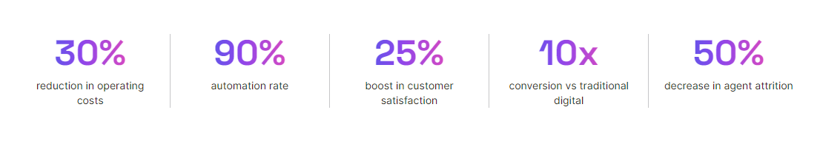

## Summary

Cohere's Multilingual Model addresses the challenges of communication barriers between humans and machines by providing a powerful tool for text analysis applications. With high-performance and accurate embeddings available in English and over 100 other languages, Cohere enables teams to build semantic search capabilities, cluster similar topics, and create recommendation engines. This allows businesses to connect and succeed worldwide by engaging users with relevant content and providing contextually appropriate responses in multiple languages. With Cohere's Multilingual Model, businesses can overcome language barriers and tap into global markets more effectively.